

FAST National University of Computer and Emerging Sciences

Thesis Proposal

Towards Improving Deep Embedded Document Clustering with long range text semantics and neighborhood documents information

Supervisor: Dr. Muhammad Rafi

Made By: S M Imran Abbas (24K-8021)
- Abstract

Document clustering is significant to structuring large volumes of unstructured text. The recent development of deep embedded clustering has enhanced the quality of clustering through learning document representations and cluster assignments together. Nevertheless, current methods tend to use graph structures and autoencoders that are usually not static, and are likely to miss long-range semantic dependencies and dynamics between documents. Besides, a significant number of graph-based methods are susceptible to the quality of constructed K nearest neighbor (KNN) graph, which results in unreliable performance in clustering.

This study presents a new improved deep embedded document clustering system which combines both long-range semantic modeling and adaptive neighborhood structure learning as a single optimization procedure. The documents are first encoded with the help of a Transformer based encoder to obtain contextual and global semantic information. A similarity based KNN graph is formed based on the learned embeddings to model document relationships. In contrast to methods based on static graphs, the suggested approach occasionally reuses the graph in the course of training to capture a new semantic representation and be less sensitive to noise in the early graph.

In order to maintain coherence between semantic and structural representations, a cross view contrastive learning task is proposed to align Transformer based semantic representations with Graph Convolutional Network (GCN) based structural representations. The resulting aligned representations are combined and optimized with a deep embedded clustering scheme student’s t-distribution soft assignments and KL divergence optimization. The whole architecture is trained with an end-to-end objective based on balancing clustering refinement, structural consistency, and contrastive alignment.

The proposed algorithm will enhance the separability, robustness and stability of clusters in document clustering tasks by integrating both the dynamic graph learning and semantic structural learning.

- Introduction

The emergence of digital text data produced by news articles, research articles, and social media sites has introduced a high demand in the domain of document clustering. Document clustering is an unsupervised learning method which uses unlabeled documents and group them into semantically coherent clusters. Its application is extensive in topic discovery, information retrieval, recommendation systems and comprehensive content management. Nevertheless, it is difficult to cluster textual data due to the high dimensionality of text representations and frequent inability to reflect substantive semantic connections.

The traditional features that were used in early clustering methods included TF-IDF and are used together with K-means. The use of contextual language models demonstrated that feature-based BERT representations were better than text features in clustering tasks [9]. It was however discovered that the performance was sensitive to the pooling and normalization strategies which showed that the quality of representation is a major aspect.

Deep embedded clustering (DEC) frameworks were offered in order to overcome representation constraints. The Structural Deep Clustering Network (SDCN) [1] suggested the joint optimization of representation learning and clustering with the student’s t-distribution and the KL divergence. Subsequent applications like DSEDC [2] and AGCN [3] took this concept a notch higher and added Graph Convolutional Networks (GCNs) to the concept to represent structural relations between documents. The studies have shown that the combination of semantic and structural information can greatly enhance the effectiveness of clustering.

Transformer-based embeddings have recently been incorporated into deep clustering models. Semantic Deep Embedded Clustering (SDEC) [4] used BERT representations with DEC-style clustering that enhanced the preservation of semantic structure. Equally, the Structural Semantic Network, an architecture which employed Transformer and GCN-based structural modeling, was Deep Transformer-based [5]. Although these models had good performance, it was noted to be sensitive to the quality of KNN graph and had a scaling problem [5]. Graph techniques have also been sensitive to graph construction thresholds and structural noise [6].

Manifestation manifold refinement and multi-view semantic improvement were examined by other studies. The clustering of MDCE [7] was enhanced by complementary semantic views and Refined SBERT [8] enhanced embedding geometry by neighborhood-preserving methods. Also, contrastive learning that has been adapted has demonstrated that alignment of representations can enhance performance in clustering in low-resource scenarios [10].

Although, current techniques tend to be based on fixed graph models and scanty communication between semantic and structural representations modules. These constraints inspire the current study, which presents a single framework that combines Transformer based semantic modelling and dynamically reconstructed neighborhood graphs and contrastive learning in a deep embedded clustering objective. It aims at enhancing the semantic-structural co-learning to enhance cluster separability, robustness and stability in document clustering.

- Literature Review

Initial advances in document clustering were concerned with the use of the improved text representations. The article "The performance of BERT as data representation of text clustering" [9] demonstrated that contextual BERT embeddings had remarkable results in comparison with other feature representations like TF-IDF on various clustering methods. It also pointed out that performance of clustering module is very sensitive to pooling and normalization strategies. This shows that the quality of representation does not ensure stable clustering. In order to mitigate this situation, the frameworks of deep embedded clustering (DEC) were proposed. Structural Deep Clustering Network (SDCN) [1] offered a joint optimization model that combines the autoencoders-based representation learning with clustering by using a student’s t-distribution based soft assignments and KL divergence. This represented a shift from two stage clustering to a unified end to end optimization technique. This was later elaborated/developed in subsequent work like Deep Structural Enhanced Network for Document Clustering (DSEDC) [2], which added further structural information in the form of graphs to the learning process and enhanced the strength to cluster.

The establishment of structural relations between documents became one of the leading strategies in enhancing the quality of clustering. Graph Convolutional Networks (GCNs) were combined with autoencoders in SDCN [1] to learn deep structural information. Similarly, DSEDC [2] used the semantic representations and structural features learned by GCNs with external, internal semantics, and optimized them together. Attention based Graph Clustering Network (AGCN) [3] added attention to dynamically combine attribute and structural representations, which overcomes over-smoothing in graph learning. These articles show that the use of neighborhood information can improve the performance of clustering. They however also complain that they are sensitive to the quality of the constructed graphs and that noise propagation may occur along structural layers. More recently, Graph-Convolutional Networks: Named Entity Recognition and Large Language Model Embedding in Document Clustering [6] gave embedding based on the LLM and entity-based graph building, with better results compared with conventional KNN-based techniques. However, this method involves delicate threshold tuning when constructing graphs, which suggests that structural modeling is Hyperparameter sensitive.

Transformer-based embeddings have taken over as the key to document clustering with the success of contextual models. BERT embeddings were combined with a DEC-style clustering system with Semantic Deep Embedded Clustering (SDEC) [4], which optimized representation learning along with cluster assignments. This was better at semantic preservation, and was said to be expensive to compute and sensitive to initialization. Further Structural Semantic Network Deep Transformer-based Structural Semantic Network (DTSN) [5] added GCN-based structural modeling to Transformer encoders and combined semantic and structural embeddings in a combined optimization framework. Although it has shown good clustering performance, it has been reported to have weaknesses such as relying on the quality of KNN graph, scaling limitations and assumption of static embedding. These works corroborate that Transformers are efficient at capturing long-range semantic dependencies, whereas structural integration and optimization stability is problematic.

In addition to direct graph modeling, other works enhanced clustering through better embedding geometry. These were complemented with Deep Multi-View Document Clustering with Enhanced Semantic Embedding (MDCE) [7], which enhanced semantics by relying on neighbor-based and cross-view autoencoders, then clustering with the DEC approach. This method solved the view inconsistency and resulted in the enhancement of convergence stability. Neighborhood Preserving Embedding (NPE) was introduced by the refined SBERT [8] to re-embed sentence representations into a manifold space, followed by the local geometric structure, and then subjecting the inputs to K-means clustering. Though effective to enhance semantic consistency, it needs extra computational procedures and hyperparameter optimization. The approaches demonstrate that the performance of clustering can be improved by the improved structure and geometry even in the absence of explicit structural graphs.

Recently, contrastive learning has been used to develop better representations. Domain-Adapted Contrastive Learning [10] used contrastive goals together with domain adaptation to enhance low-resource language clustering. Though it greatly enhanced the embedding quality, clustering was carried out in a sequential manner through HAC and K-means and not in an integrated deep clustering approach. This indicates that contrastive learning enhances semantic representation but it is seldom directly incorporated into joint semantic-structural deep clustering systems.
There are a number of recurring trends in the literature:

- Student’s t-distribution and KL divergence to cluster into deterministic coherent clusters are popularly used in the DEC-style [1], [2], [3], [4], [5], [7].
- GCNs improve the quality of clustering, yet they are vulnerable to the quality of graph construction [1], [5], [6].
- Transformer-based embeddings are better at modeling semantics over long distances, but they present computational complexity and stability issues [4], [5].
- Contrastive learning yields better representation matching but is not used with unified deep clustering optimization [10].
- Multi-view and manifold refinements are better at embedding geometry, but nonetheless do not resolve dynamic structural learning [7], [8].

These results suggest that, although semantic modeling and structural learning have been considerably developed, current options tend to use the neighborhood graph as a static element and insufficient interaction of both semantic and structural perspectives. This encourages more studies on the possibility of coming up with unified models that dynamically model document relationships and still be semantically consistent.

- Research Gap and Research Questions

Although there has been a lot of advancement in deep document clustering, there are still a number of methodological limitations that have not been addressed.

First, most of the deep embedded clustering models are based on the graph constructions that are constructed statically to model structural relationships among documents. The models that combine Graph Convolutional Networks (GCNs) with semantic encoders include SDCN [1], DSEDC [2], and Deep Transformer-based Structural Semantic Network [5], all of which have been found to be sensitive to the quality of the KNN graphs and structural noise. As these graphs are built prior to or early in training, they are not necessarily indicative of improved semantic representations that are learned during optimization. This design is rigid and constrained and can potentially spread noise at an initial level to all of training.

Second, despite being able to preserve rich long-range semantic dependencies, Transformer-based models like SDEC [4] and DTSN [5] are designed to enhance the quality of their representation, but do not fully resolve the issue related to the evolving relationship between semantic embeddings and neighborhood structure. Semantic learning and structural modeling are typically combined, or co-optimized, but explicit mechanisms to enforce consistency in these two perspectives are still rare.

Third, the issue of contrastive learning has been addressed to improve the alignment of the representations, as demonstrated in Domain-Adapted Contrastive Learning [10]. Nevertheless, these methods use conflicting goals sequentially, and place them not in an integrated deep embedded clustering system that optimizes semantic modeling, structural learning, and clustering refinement simultaneously.

Also, the current graph-based clustering algorithms are also vulnerable to the hyperparameter and threshold choice when building the graph as documented in [1], [5], and [6]. It means that there is no strength in neighborhood modeling strategies.

In general, existing methods (1) use fixed structural graphs, (2) do not provide explicit semantic-structural alignment schemes or (3) incorporate contrastive learning outside of the optimization of the clustering process. Minor research has been done into the frameworks that dynamically polyphase or update structures of neighborhoods during training, and which also establish semantic-structural conformity in a single deep embedded clustering task.

In order to fill the above research gaps, the following research questions can be suggested.

- Do periodic reconstructions of the K-nearest neighbor (KNN) graph during training result in a better performance in clustering than using the fixed graph construction in deep embedded document clustering models?
- Does adding cross-view contrastive learning between Transformer-based semantic embeddings and GCN-based structural embeddings improve cluster separability and consistency of representations?
- Does a dynamic neighborhood model enhance greater robustness to graph noise and sensitivity to hyperparameter choice in document clustering tasks?

- Problem Statement

Existing DEC algorithms enhance learning of representations via structural graph modeling and semantic embedding. Nonetheless, numerous methods are based on fixed neighborhood graphs, and do not explicitly match between semantic and structural representations, which are sensitive to graph noise, and constraining the flexibility during training. It is necessary to have a common clustering model that dynamically redefines the relationships of documents and imposes semantic-structural consistency to enhance robustness and stability of clustering.

- Proposed Research Methodology

- Benchmark Dataset: Evaluation and comparison will be conducted using datasets in public document clustering (e.g., BBC, Reuters, ACM, AG News).

- Data Preparation: Raw documents will be cleaned, and tokenized by Transformer tokenizer before being converted into model-ready inputs.

- Semantic Representation Learning: A Transformer encoder will produce semantic contextual document embeddings that span long-range semantic information.

- Dynamic KNN Graph Construction: A KNN graph based on similarity will be built using semantic embeddings and rebuilt every periodically as the training goes on.

- Structural Representation Learning through GCN: Graph network will learn the dynamic graph neighborhood-aware structural embeddings.

- Cross-View Contrastive Alignment: A batch contrastive loss will be used to match semantic and structural embeddings in order to impose representation consistency.

- Representation Fusion: The semantic and structural representations will be mixed to get unified document representations.

- Deep Embedded Clustering: The student’s t-distribution-based soft assignment with the optimization of the KL-divergence will optimize the cluster assignment.

- Joint Optimization: The model will be trained in an end-to-end fashion with a composite clustering, structural and contrastive loss.

- Model Evaluation: The ACC, NMI and ARI will serve as metrics of performance, with which to determine the strength of the contribution of each component and its importance.

- Block diagram of proposed research methodology

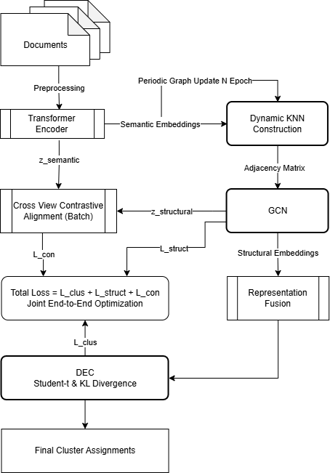
Figure 1: Flow Diagram of proposed method

- Project Timeline

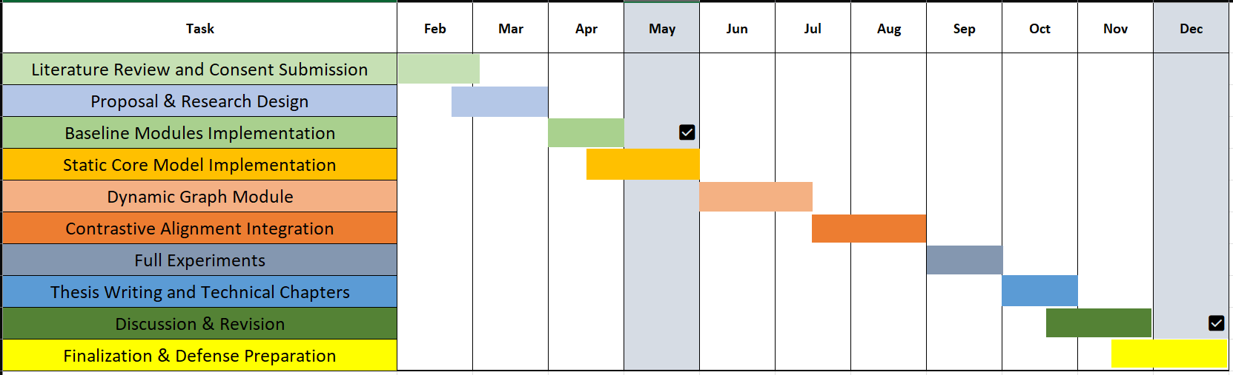

Figure 2: Project Tentative Timeline Gantt

- References

[1] Bo, Deyu, Xiao Wang, Chuan Shi, Meiqi Zhu, Emiao Lu, and Peng Cui. "Structural deep clustering network." In Proceedings of the web conference 2020, pp. 1400-1410. 2020.

[2] Ren, Lina, Yongbin Qin, Yanping Chen, Ruina Bai, Jingjing Xue, and Ruizhang Huang. "Deep structural enhanced network for document clustering." Applied Intelligence 53, no. 10 (2023): 12163-12178.

[3] Peng, Zhihao, Hui Liu, Yuheng Jia, and Junhui Hou. "Attention-driven graph clustering network." In Proceedings of the 29th ACM international conference on multimedia, pp. 935-943. 2021.

[4] Rahman, Mohammad Wali Ur, Ric Nevarez, Lamia Tasnim Mim, and Salim Hariri. "SDEC: Semantic Deep Embedded Clustering." IEEE Transactions on Big Data (2025).

[5] Amir, Umair, Faizan Ali, Ali Ahmed, and Muhammad Rafi. 2025. Deep Transformer-Based Structural Semantic Network for Document Clustering. National University of Computer and Emerging Sciences, Karachi, Pakistan.

[6] Keraghel, Imed, and Mohamed Nadif. "Graph-Convolutional Networks: Named Entity Recognition and Large Language Model Embedding in Document Clustering." In European Conference on Information Retrieval, pp. 88-103. Cham: Springer Nature Switzerland, 2025.

[7] Bai, Ruina, Ruizhang Huang, Yanping Chen, and Yongbin Qin. "Deep multi-view document clustering with enhanced semantic embedding." Information Sciences 564 (2021): 273-287.

[8] Chu, Yonghe, Heling Cao, Yufeng Diao, and Hongfei Lin. "Refined SBERT: Representing sentence BERT in manifold space." Neurocomputing 555 (2023): 126453.

[9] Subakti, Alvin, Hendri Murfi, and Nora Hariadi. "The performance of BERT as data representation of text clustering." Journal of big Data 9, no. 1 (2022): 15.

[10] Zaikis, Dimitrios, and Ioannis Vlahavas. "DACL+: domain-adapted contrastive learning for enhanced low-resource language representations in document clustering tasks." Neural Computing and Applications 37, no. 17 (2025): 10577-10590.

